**WEEK 7_REACT HANDSON**

**Exercise 1:** Create a React Application named cricketapp

**Scenario:**

Declare an array with 11 players and store details of their names and scores using the map feature of ES6. Filter the players with scores below 70 using arrow functions of ES6. Display the Odd Team Player and Even Team players using the Destructuring features of ES6

**CODE:**

**Account:**

**App.js :**import React from 'react';

import './App.css';

import CalculateScore from './Components/CalculateScore';

function App() {

  return (

    <div className="App">

      <CalculateScore

        name="vijay"

        school="Government High School"

        total={450}

        goal="Become a Software Engineer"

      />

    </div>

  );

}

export default App;

**Calculatorapp.js:**

import React from 'react';

import '../Stylesheets/mystyle.css';

function CalculateScore(props) {

  const average = props.total / 5;

  return (

    <div className="score-container">

      <h2>Student Score Details</h2>

      <p><strong>Name:</strong> {props.name}</p>

      <p><strong>School:</strong> {props.school}</p>

      <p><strong>Total Marks:</strong> {props.total}</p>

      <p><strong>Goal:</strong> {props.goal}</p>

      <p><strong>Average Score:</strong> {average}</p>

    </div>

  );

}

export default CalculateScore;

**OUTPUT :**

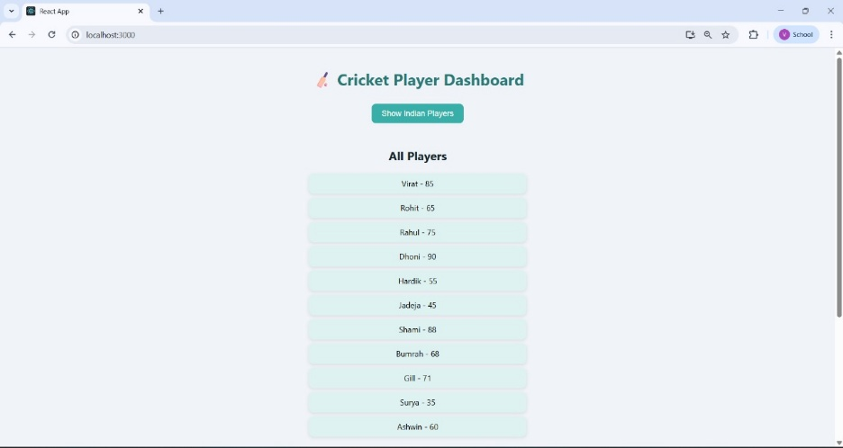

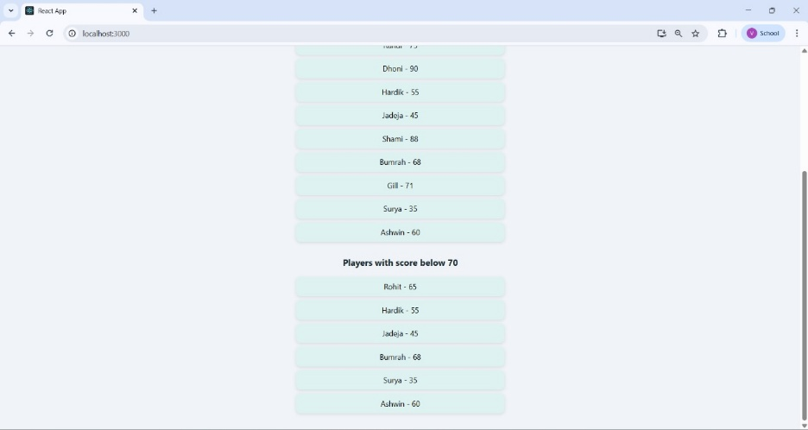

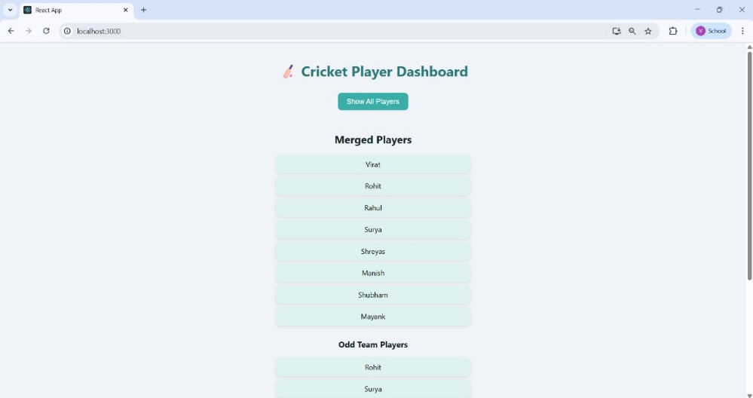

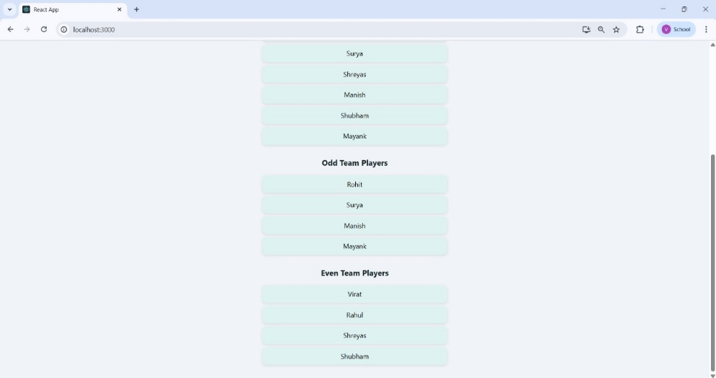

**Exercise 2: Create a React Application named “officespacerentalapp” which uses React JSX to create elements, attributes and renders DOM to display the page.**

**SCENARIO:**

Create an element to display the heading of the page. Attribute to display the image of the office space

Create an object of office to display the details like Name, Rent and Address. Create a list of Object and loop through the office space item to display more data. To apply Css, Display the color of the Rent in Red if it’s below 60000 and in Green if it’s above 60000.

**CODE:**

**App.js :**

import React from 'react';

function App() {

  const headingStyle = {

    textAlign: 'center',

    color: '#2b7a78',

    margin: '20px 0'

  };

 const officeSpaces = [

  {

    name: 'Cozy Work Hub',

    rent: 45000,

    address: '123 Business Road, Chennai',

    image: 'https://images.unsplash.com/photo-1631193816258-28b44b21e78b?q=80&w=1170&auto=format&fit=crop&ixlib=rb-4.1.0&ixid=M3wxMjA3fDB8MHxwaG90by1wYWdlfHx8fGVufDB8fHx8fA%3D%3D'

  },

  {

    name: 'Premium Office Space',

    rent: 85000,

    address: '456 Corporate Ave, Chennai',

    image: 'https://images.unsplash.com/photo-1573164713988-8665fc963095?auto=format&fit=crop&w=600&q=80'

  },

  {

    name: 'Startup Nest',

    rent: 58000,

    address: '789 Startup St, Chennai',

    image: 'https://images.unsplash.com/photo-1556740749-887f6717d7e4?auto=format&fit=crop&w=600&q=80'

}

];

  return (

    <div style={{ padding: '20px' }}>

      <h1 style={headingStyle}>🏢 Office Space Rental Portal</h1>

      {officeSpaces.map((office, index) => (

        <div

          key={index}

          style={{

            border: '1px solid #ccc',

            borderRadius: '8px',

            padding: '20px',

            margin: '20px auto',

            maxWidth: '500px',

            boxShadow: '0 4px 8px rgba(0,0,0,0.1)'

          }}

        >

          <img

            src={office.image}

            alt={office.name}

            style={{ width: '100%', height: 'auto', borderRadius: '4px' } />

          <h2>{office.name}</h2>

          <p><strong>Address:</strong> {office.address}</p>

          <p>

            <strong>Rent:</strong>{' '}

            <span style={{ color: office.rent < 60000 ? 'red' : 'green' }}>

              ₹{office.rent}

            </span>

          </p>

        </div>

      ))}

    </div>

  );}

export default App;

OUTPUT:

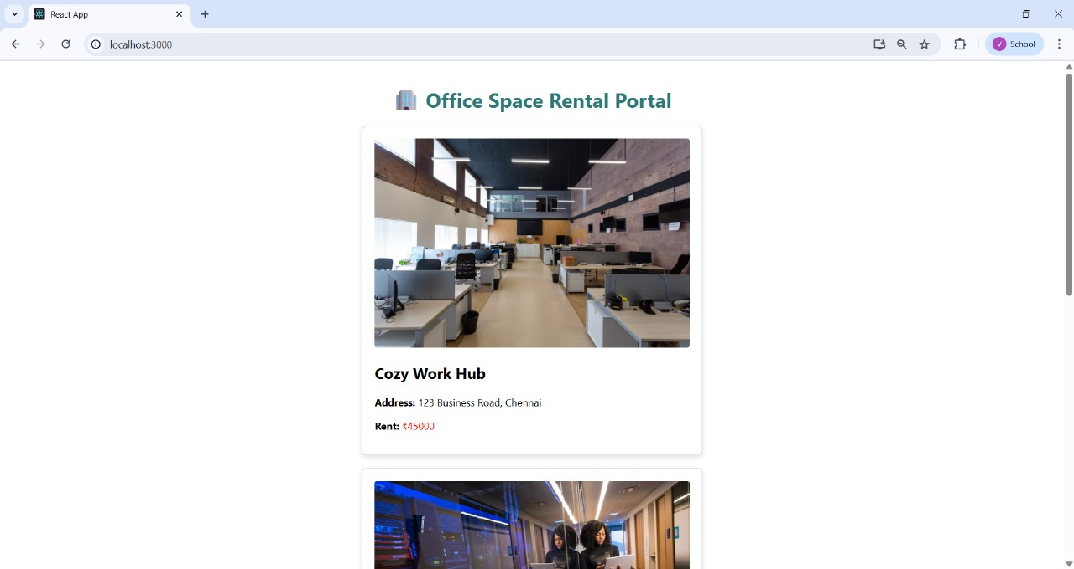

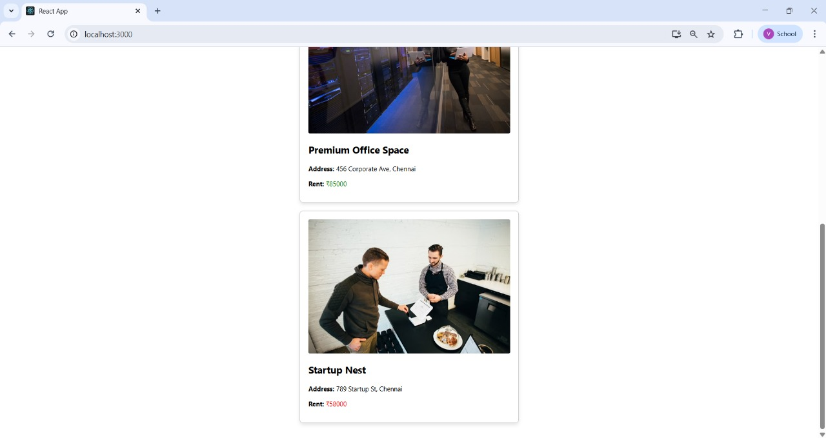

**Exercise 3: Create a React Application “eventexamplesapp” to handle various events of the form elements in HTML**

**SCENARIO:**

Create “Increment” button to increase the value of the counter and “Decrement” button to decrease the value of the counter. The “Increase” button should invoke multiple methods.

* 1. To increment the value
  2. Say Hello followed by a static message.

**CODE:**

**App.js:**

import React, { Component } from 'react';

import CurrencyConvertor from './CurrencyConvertor';

class App extends Component {

  constructor(props) {

    super(props);

    this.state = {

      count: 0

    };

  }

  increment = () => {

    this.setState({ count: this.state.count + 1 });

    this.sayHello();

    alert("Hello! Welcome !");

  };

  decrement = () => {

    this.setState({ count: this.state.count - 1 });

  };

  sayHello = () => {

    console.log("Hello! Welcome to React Event Handling Lab 🚀");

  };

  sayWelcome = (message) => {

    alert(`Message: ${message}`);

  };

  handleClick = (e) => {

    alert("I was clicked !");

    console.log("Synthetic event:", e);

  };

  render() {

    return (

      <div style={{ padding: '20px', fontFamily: 'Segoe UI' }}>

        <h1>⚙️ React Event Examples</h1>

        <h2>Counter: {this.state.count}</h2>

        <button onClick={this.increment}>Increment & Greet</button>{' '}

        <button onClick={this.decrement}>Decrement</button>

        <hr />

        <button onClick={() => this.sayWelcome("welcome")}>Say Welcome</button>

        <hr />

        <button onClick={this.handleClick}>Click Me</button>

        <hr />

        <CurrencyConvertor />

      </div>

    );

  }

}

export default App;

**OUTPUT:**

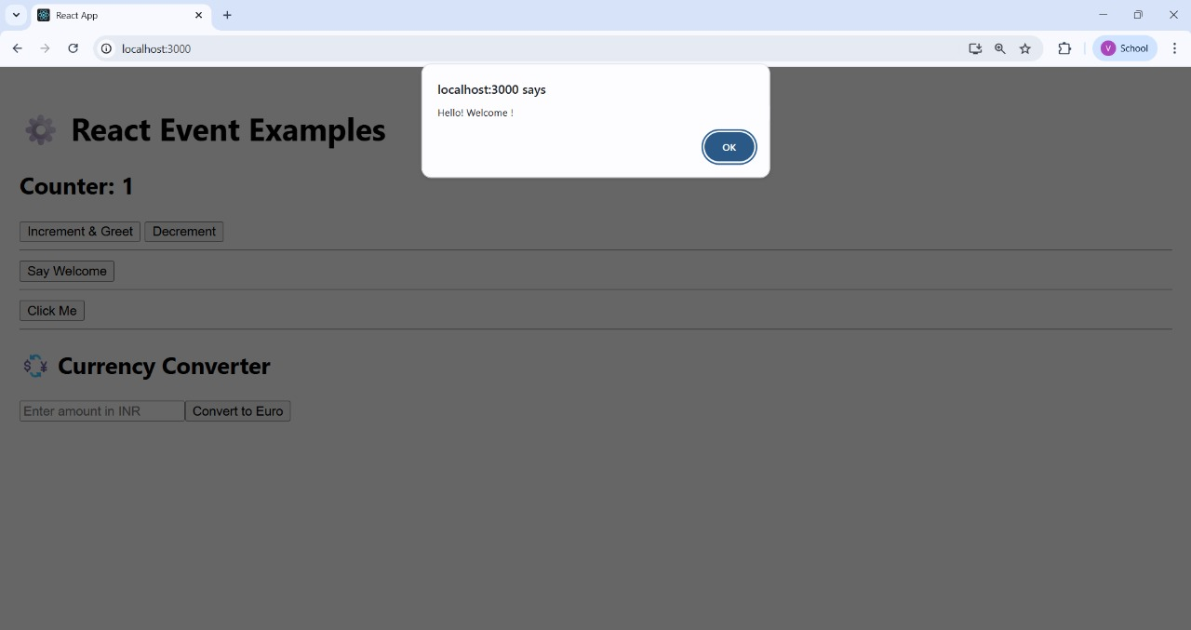

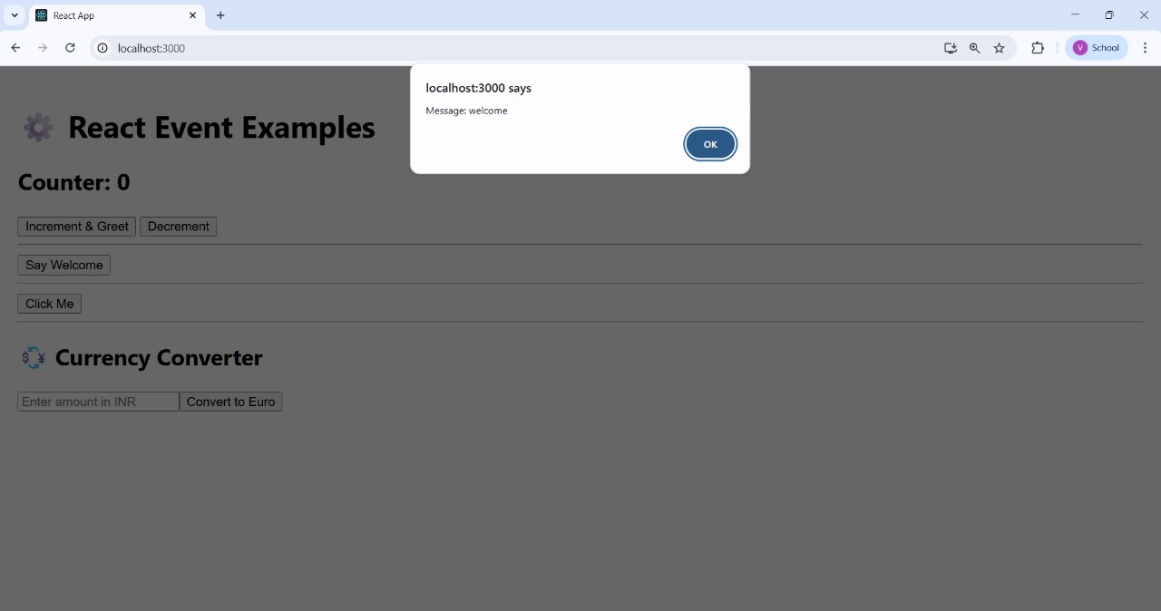

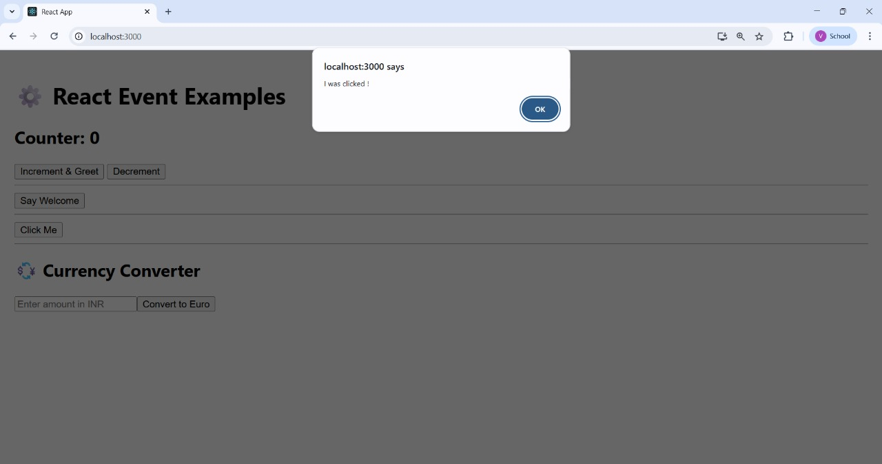

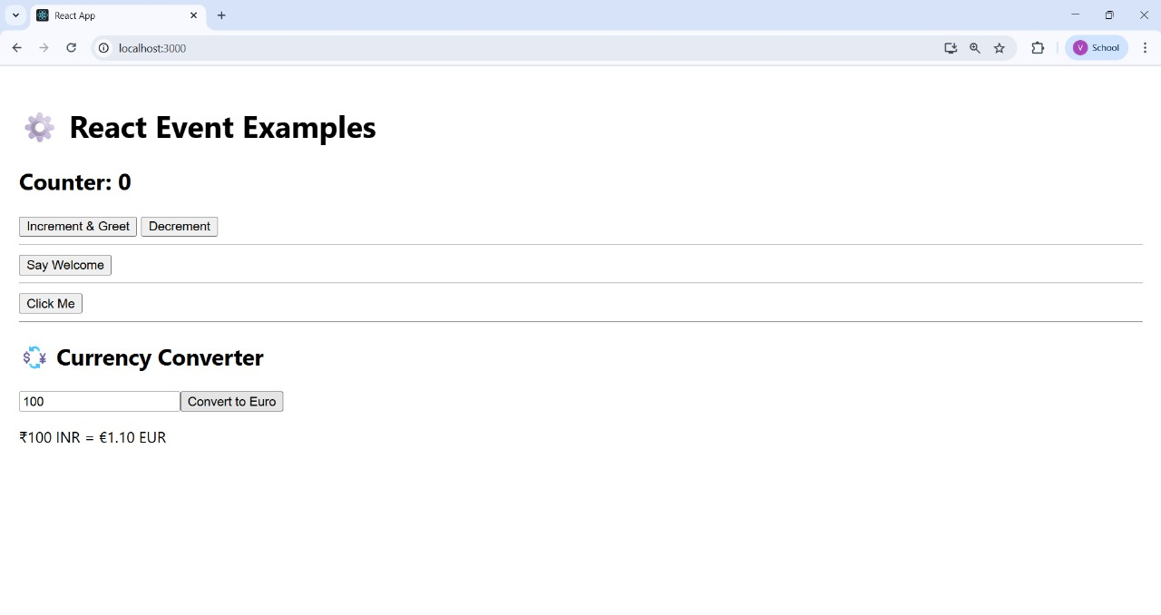

**Exercise 4: Create a React Application named “ticketbookingapp” where the guest user can browse the page where the flight details are displayed whereas the logged in user only can book tickets.**

**SCENARIO:**

The Login and Logout buttons should accordingly display different pages. Once the user is logged in the User page should be displayed. When the user clicks on Logout, the Guest page should be displayed.

**CODE:**

**App.js:**

import React, { useState } from 'react';

function GuestPage() {

  return (

    <div>

      <h2>Welcome, Guest ✈️</h2>

      <p>You can browse flight details here.</p>

    </div>

  );

}

function UserPage() {

  return (

    <div>

      <h2>Welcome, User 👤</h2>

      <p>You can now book your tickets!</p>

    </div>

  );

}

function App() {

  const [isLoggedIn, setIsLoggedIn] = useState(false);

  let page;

  if (isLoggedIn) {

    page = <UserPage />;

  } else {

    page = <GuestPage />;

  }

  return (

    <div style={{ textAlign: 'center', fontFamily: 'Segoe UI', padding: '20px' }}>

      <h1>🛫 Ticket Booking App</h1>

      {page}

      <button

        onClick={() => setIsLoggedIn(!isLoggedIn)}

        style={{

          marginTop: '20px',

          padding: '10px 20px',

          fontSize: '16px',

          backgroundColor: isLoggedIn ? '#e74c3c' : '#2ecc71',

          color: 'white',

          border: 'none',

          borderRadius: '8px',

          cursor: 'pointer'

        }}

      >

        {isLoggedIn ? 'Logout' : 'Login'}

      </button>

    </div>

  );

}

export default App;

**OUTPUT:**

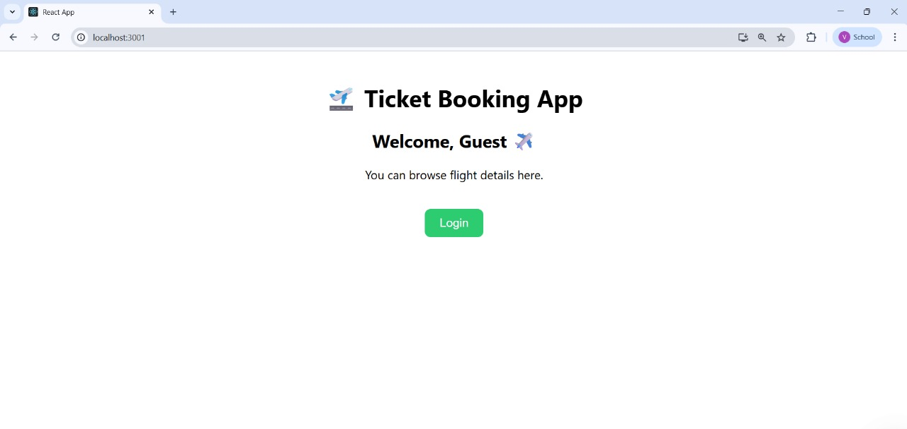

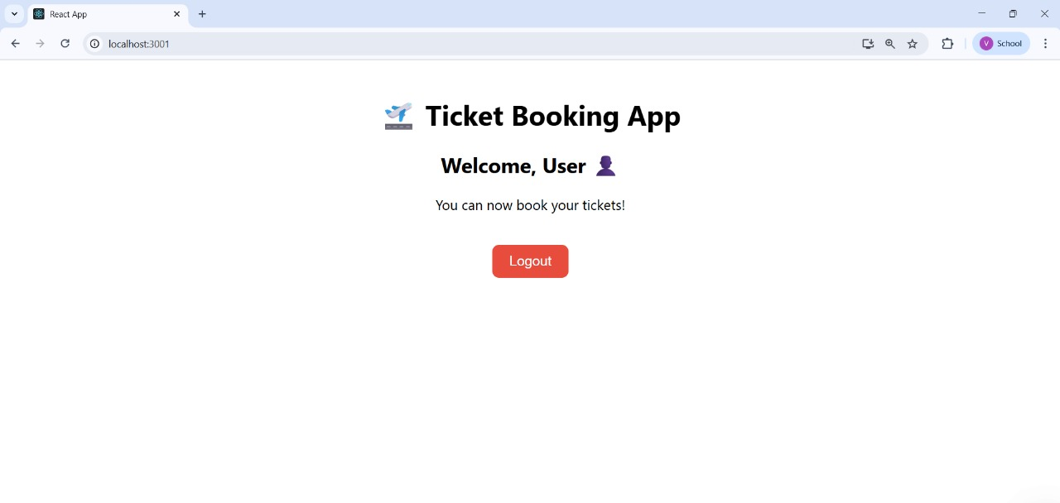

**Exercise 5: Create a React App named “bloggerapp”**

**SCENARIO:**

Create a React App named “bloggerapp” in with 3 components.

1. Book Details
2. Blog Details
3. Course Details

Implement this with as many ways possible of Conditional Rendering.

**CODE:**

**App.js**:

import React, { useState } from 'react';

const BookDetails = () => (

<div>

<h2>📚 Book Details</h2>

<p>React for Beginners by John Doe</p>

</div>

);

const BlogDetails = () => (

<div>

<h2>✍️ Blog Details</h2>

<p>Top 10 React Tips - Published on Dev.to</p>

</div>

);

const CourseDetails = () => (

<div>

<h2>🎓 Course Details</h2>

<p>React Mastery Course - Udemy</p>

</div>

);

function App() {

const [view, setView] = useState('book');

let displayComponent;

if (view === 'book') {

displayComponent = <BookDetails />;

} else if (view === 'blog') {

displayComponent = <BlogDetails />;

} else {

displayComponent = <CourseDetails />;

}

return (

<div style={{ textAlign: 'center', fontFamily: 'Segoe UI', padding: '20px' }}>

<h1>📘 Blogger App</h1>

<div style={{ marginBottom: '20px' }}>

<button onClick={() => setView('book')}>Show Book</button>{' '}

<button onClick={() => setView('blog')}>Show Blog</button>{' '}

<button onClick={() => setView('course')}>Show Course</button>

</div>

{displayComponent}

<div style={{ marginTop: '30px' }}>

<h3>🔀 Ternary Rendering</h3>

{view === 'book' ? <p>Viewing: Book</p> : view === 'blog' ? <p>Viewing: Blog</p> : <p>Viewing: Course</p>}

</div>

<div style={{ marginTop: '20px' }}>

<h3>✅ Short Circuit Rendering</h3>

{view === 'course' && <p>You are learning React Courses</p>}

</div>

</div>

);

}

export default App;

**OUTPUT:**

